**Name:** Chandana Ramesh Galgali **Batch:** TY IT B–1 **Roll No.:** 16010422234

**______________________________________________________________________________**

**Exploring MS Excel Data Analysis Tool pack**

**______________________________________________________________________________**

**1. To generate the results of the simulation:**

a. Open a new Excel spreadsheet.

b. Enter a heading at the top of a column, if desired.

c. Under “Tools” click on “Data Analysis.”

d. Find “Random Number Generation,” and double-click on it or highlight it and click OK.

**2. Implement ANY TWO following simulations:**

**a. To simulate rolling a six-sided die 100 times.**

b. To simulate 500 at-bats for a baseball player with a 0.320 batting average.

A result of 1 means a hit, 0 means an out.

c. To simulate a basketball player with a 70% free-throw average shooting ten free throws, 1000 times.

The result in each row is the number of made free throws (0 – 10) out of 10 attempts.

**d. To simulate rolling two six-sided dice and recording the sum 250 times.**

**3. To tally the results in a table and create a histogram from the table:**

a. Under tools click on “Data Analysis.”

b. Find “Histogram,” and double-click or highlight and click OK.

c. Leave the table created by “Histogram” highlighted and click on the Chart Wizard icon. You may simply click “Next” all the way through the wizard, unless you want to change or add something.

**______________________________________________________________________________**

**a. To simulate rolling a six-sided die 100 times.**

Open Excel, Set Up the Columns (Roll Number, Die Roll Results) and Probability Distribution of the Die Roll Results.

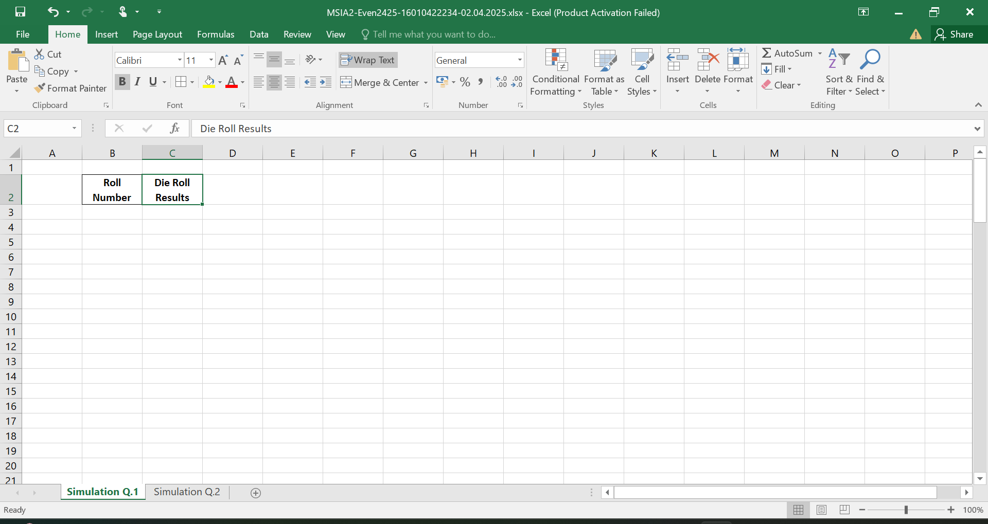

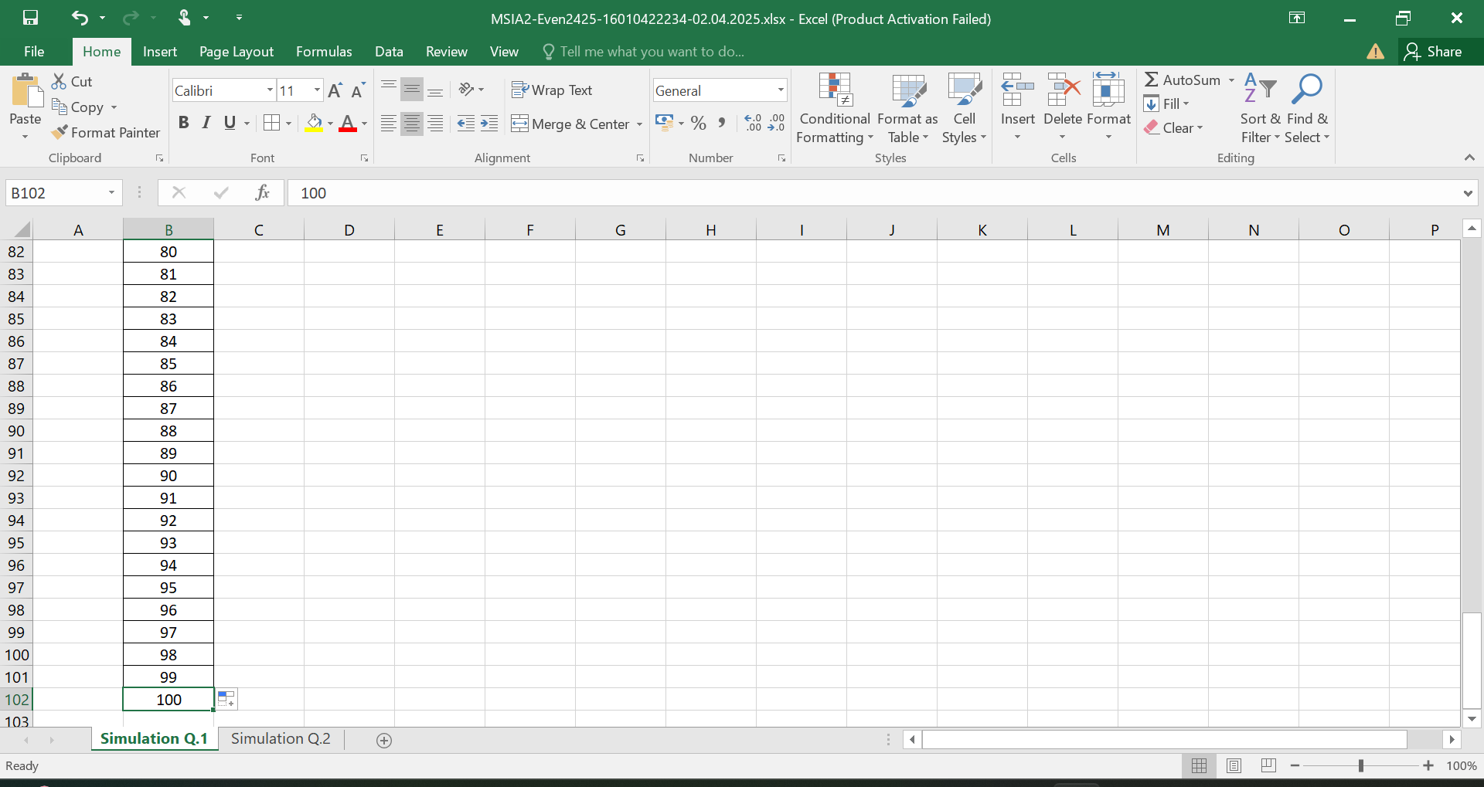

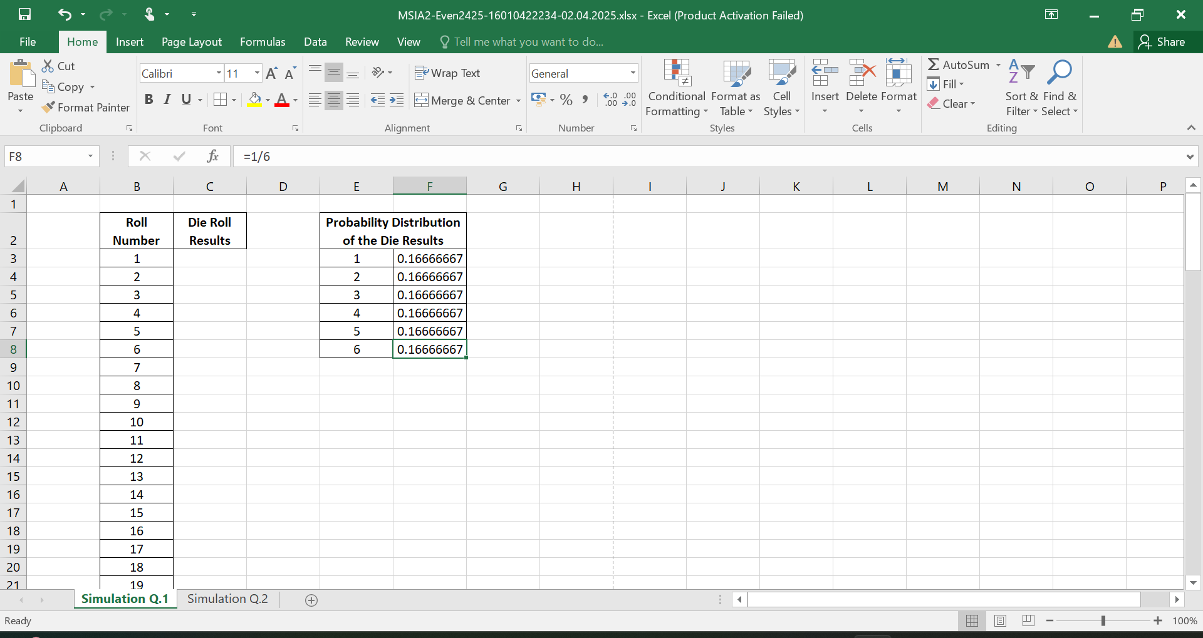

Click on Data Analysis and select Random Number Generation.

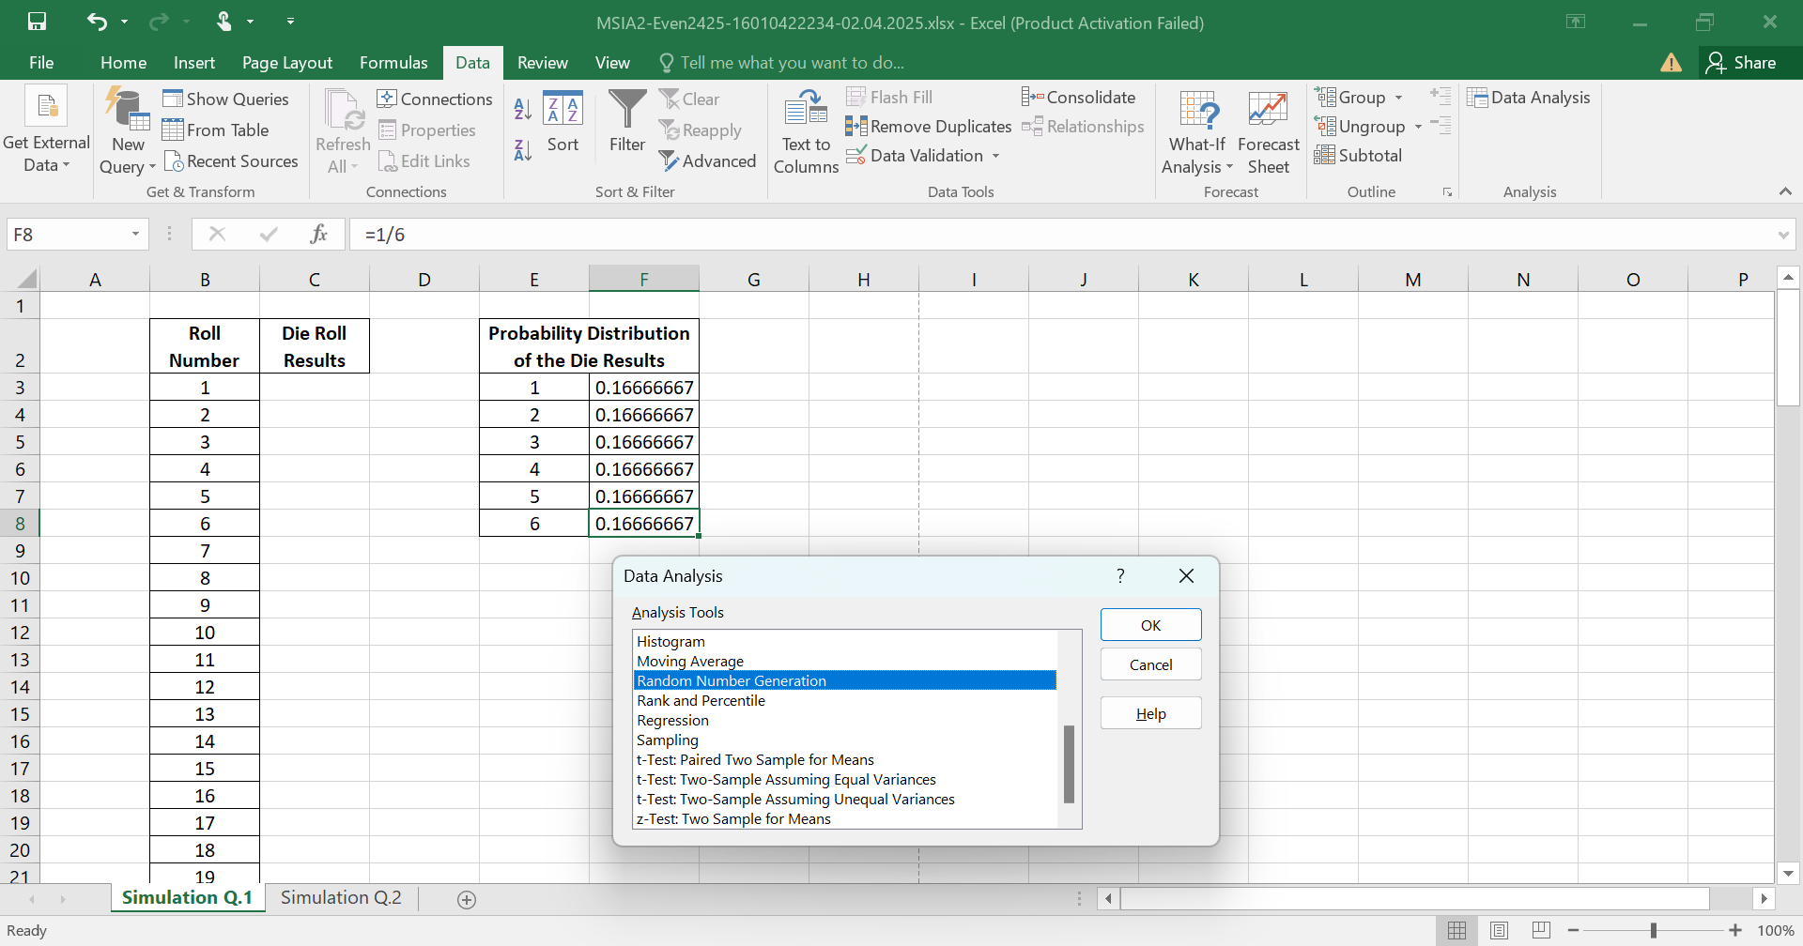

In the Random Number Generation window:

Set Number of Variables to 1 (for one die roll).

Set Number of Random Numbers to 100 (for 100 die rolls).

Set Distribution to Discrete.

Select the Value and Probability Input Range.

Select an Output Range.

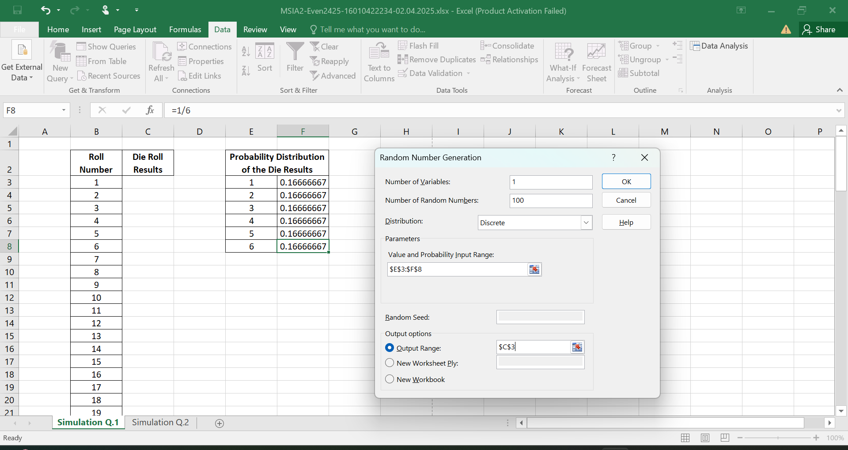

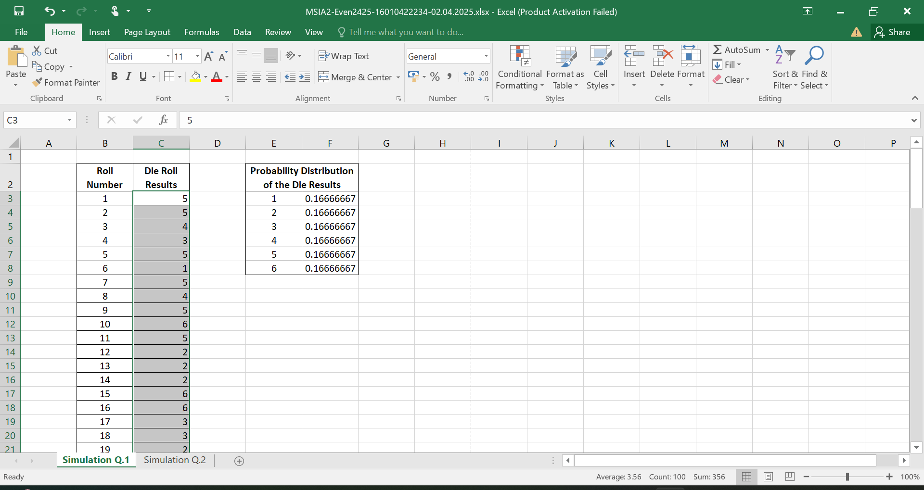

Creating Bins for the Histogram.

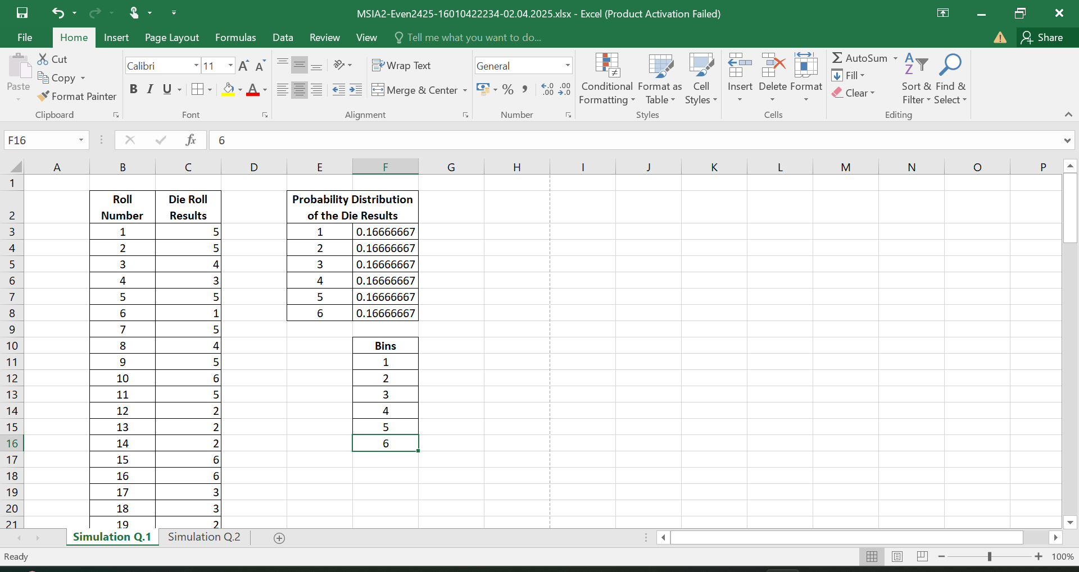

Click on Data Analysis and Open the Histogram Tool.

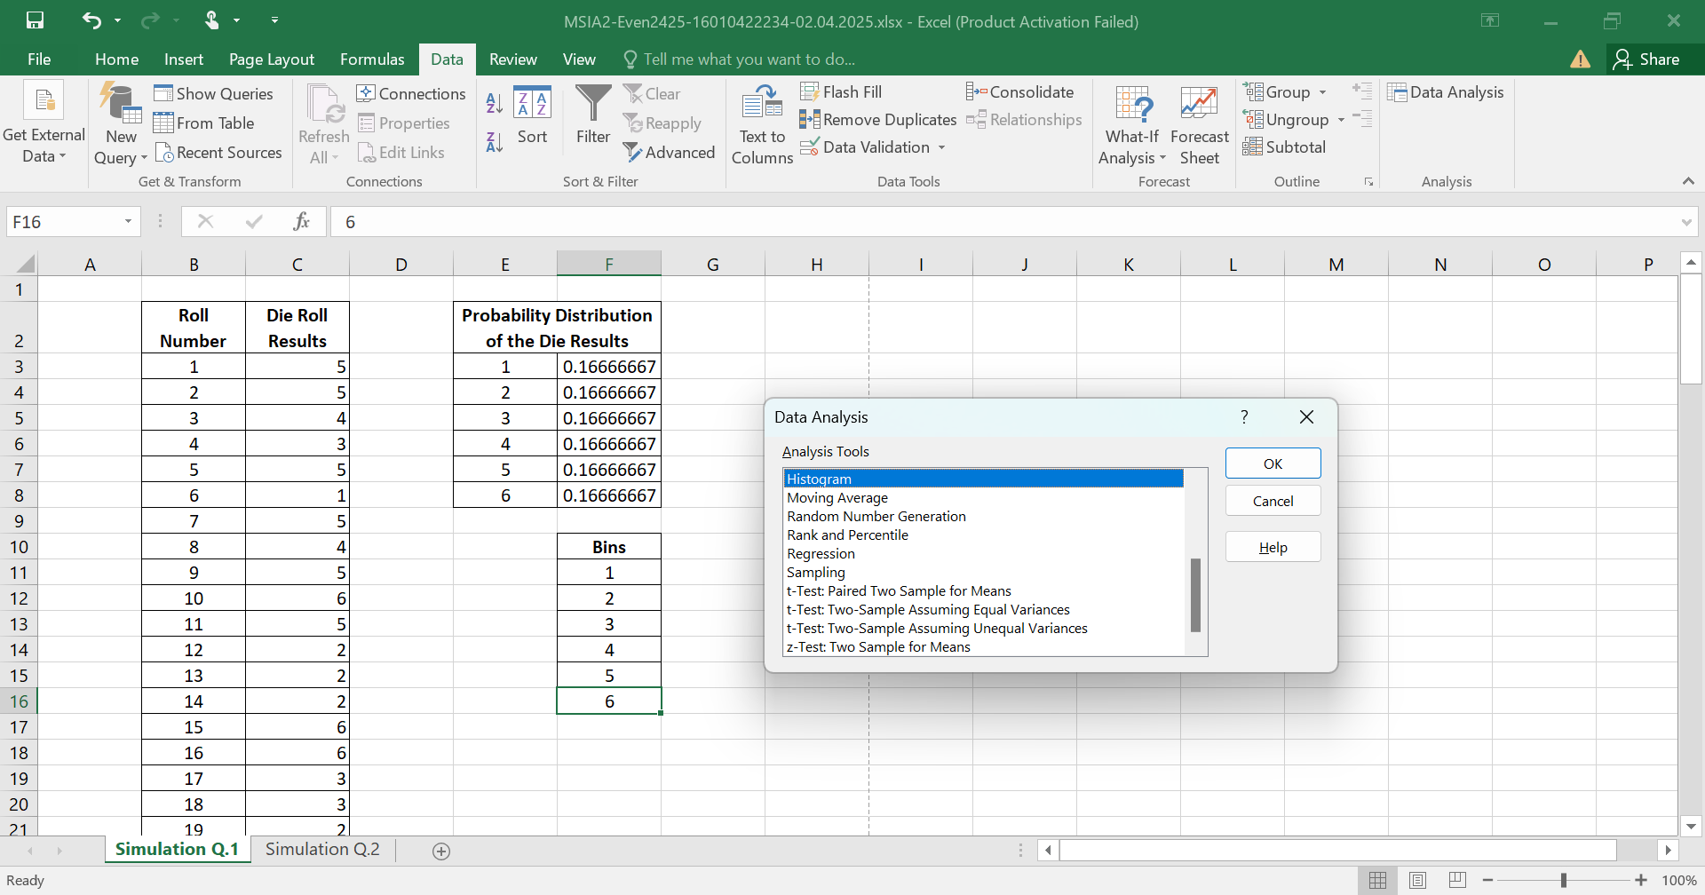

Configure the Histogram Settings:

Input Range: Select the column with the die rolls.

Bin Range: Select the bins created.

Check Labels if your selection includes column headers.

Choose Output Range and select an empty area in the current sheet.

Check Chart Output to create a histogram chart automatically.

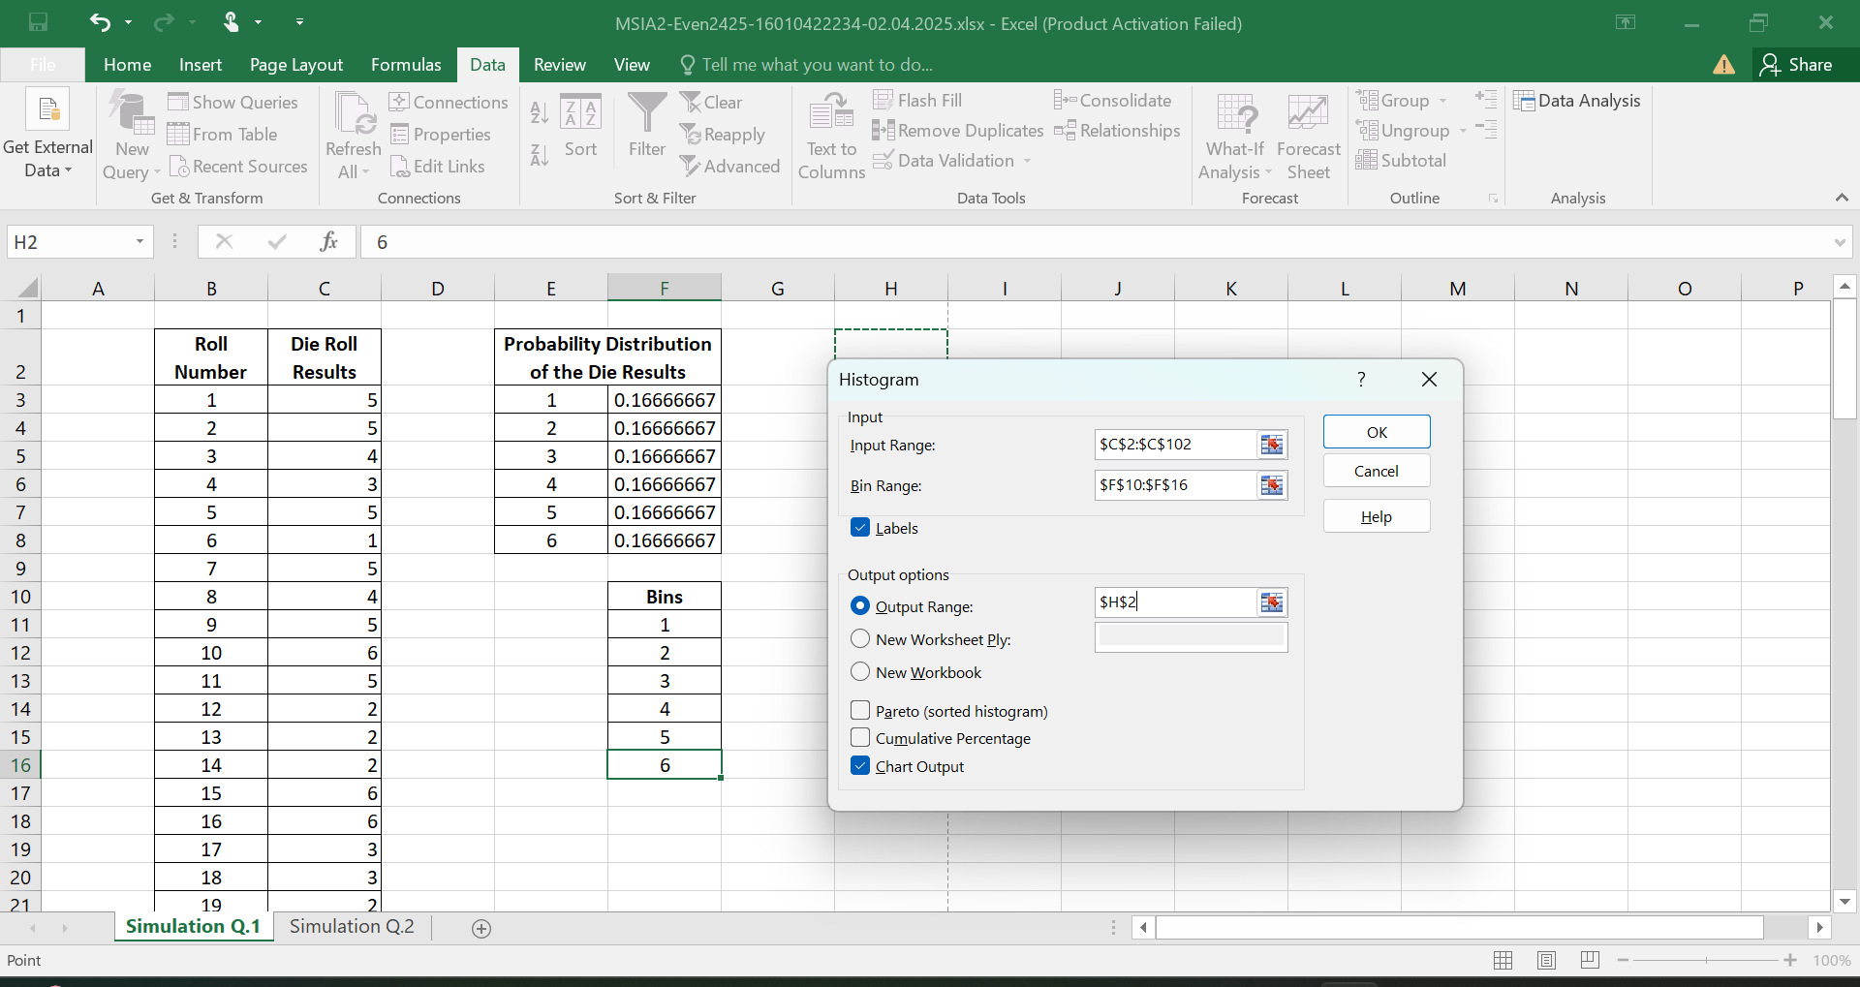

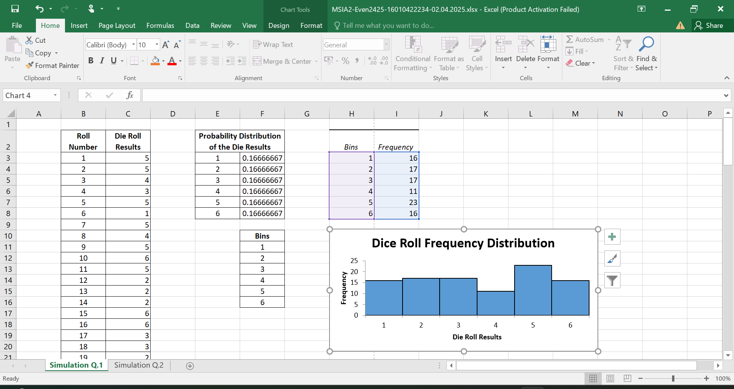

**d. To simulate rolling two six-sided dice and recording the sum 250 times.**

Open Excel, Set Up the Columns (Roll Number, Die Roll Results) and Probability Distribution of the Die Roll Results.

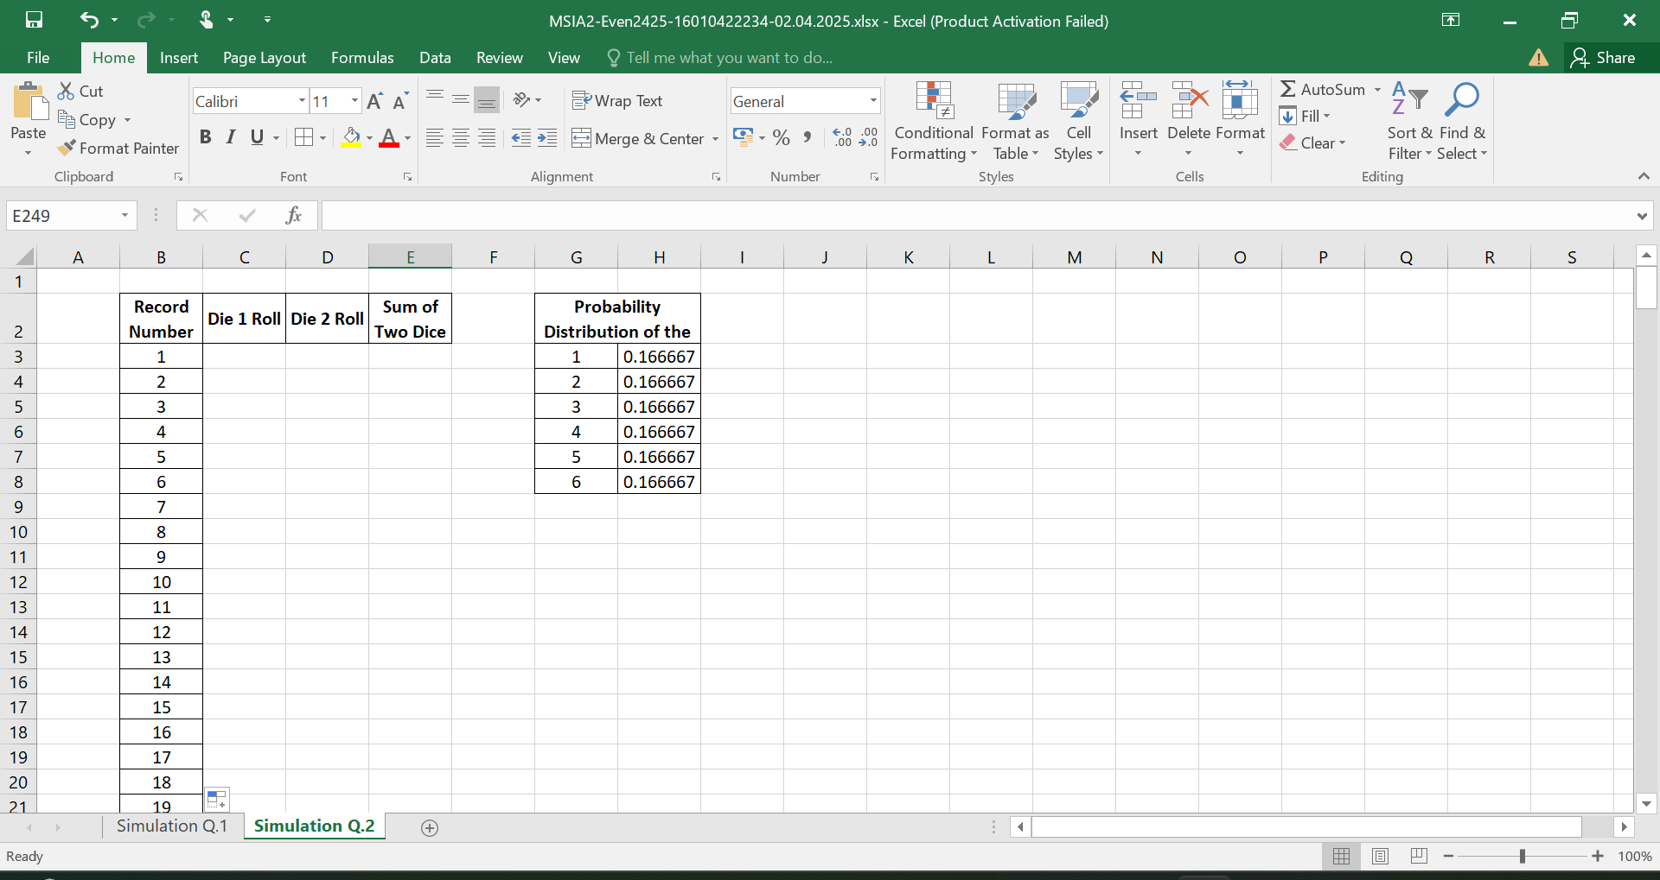

Click on Data Analysis and select Random Number Generation.

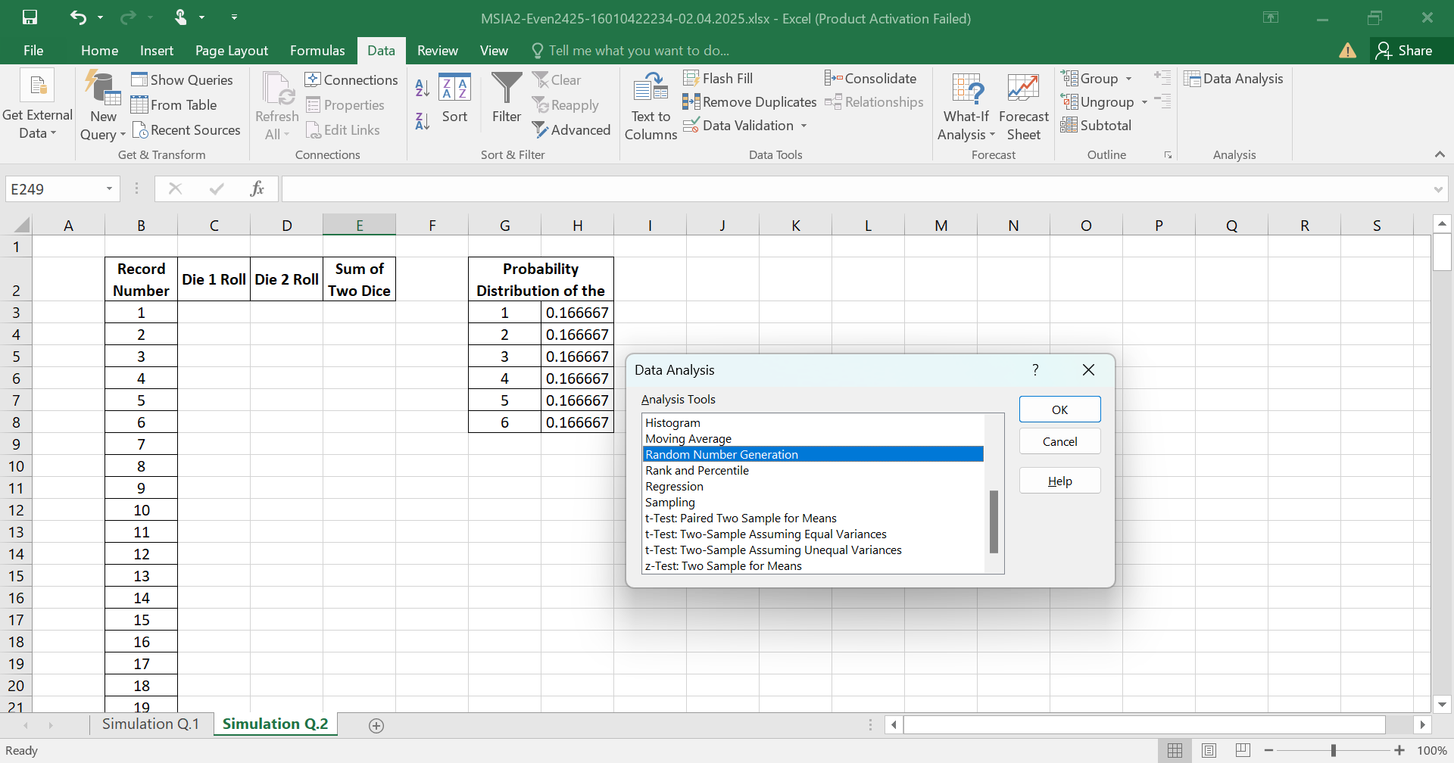

In the Random Number Generation window:

Set Number of Variables to 2 (for two die rolls).

Set Number of Random Numbers to 250 (for 250 dice sums).

Set Distribution to Discrete.

Select the Value and Probability Input Range.

Select an Output Range.

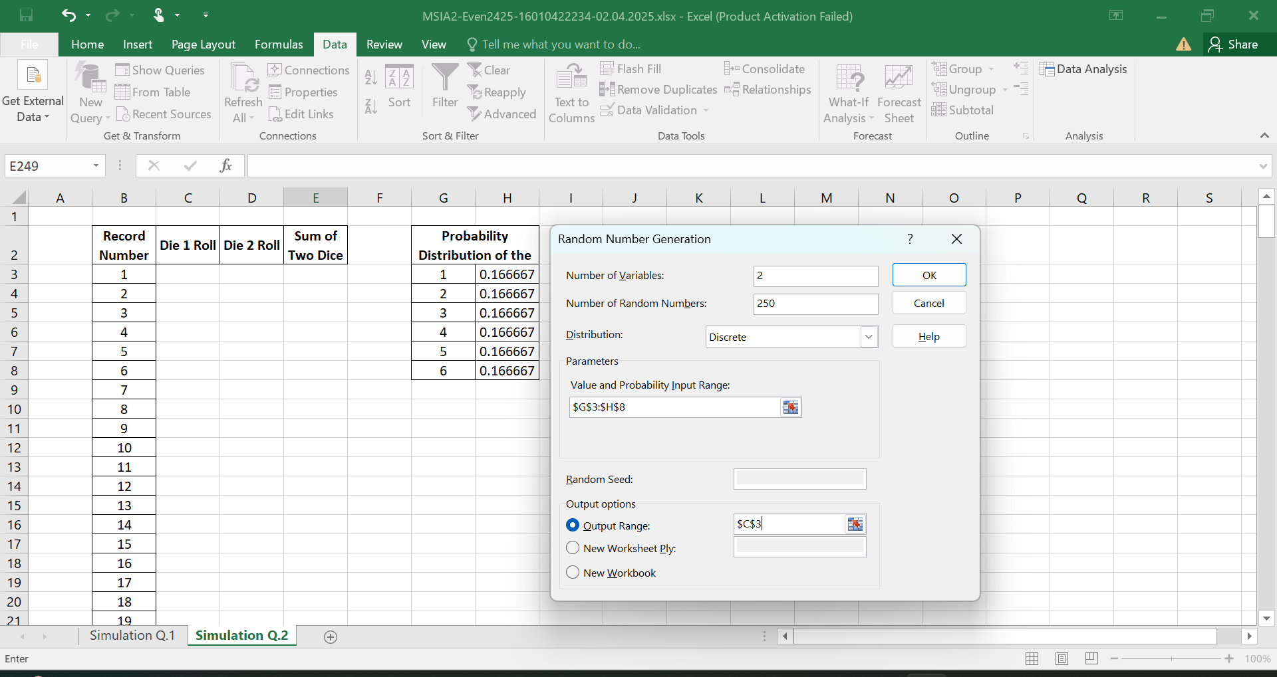

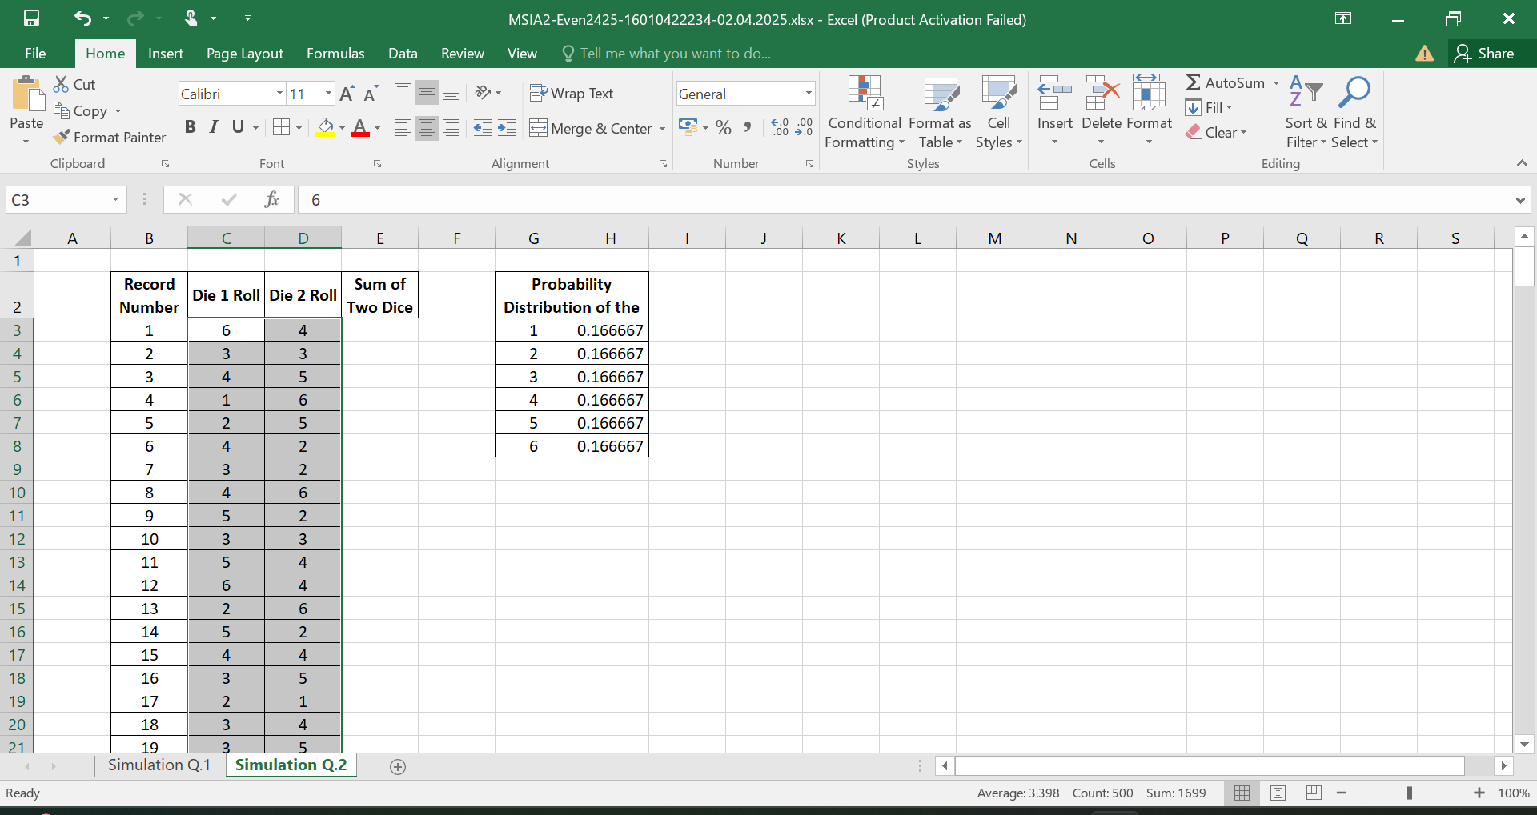

Calculate the sum of the two dice rolls.

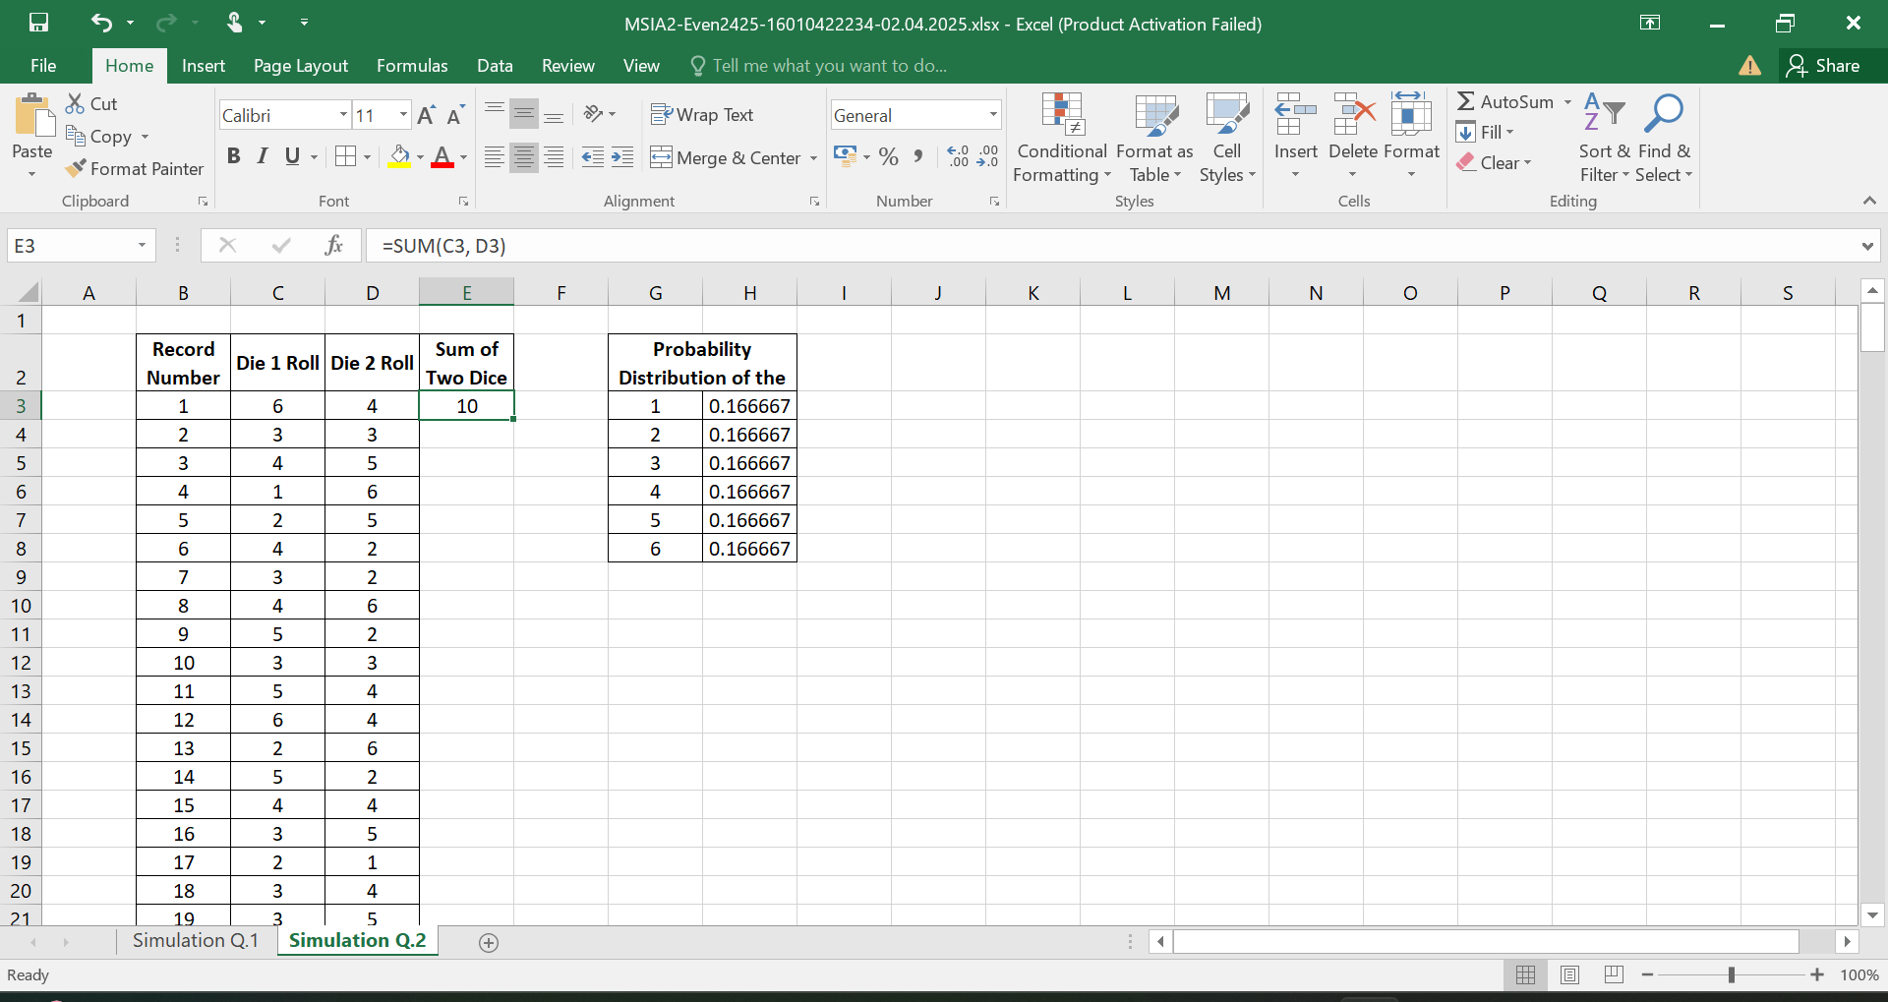

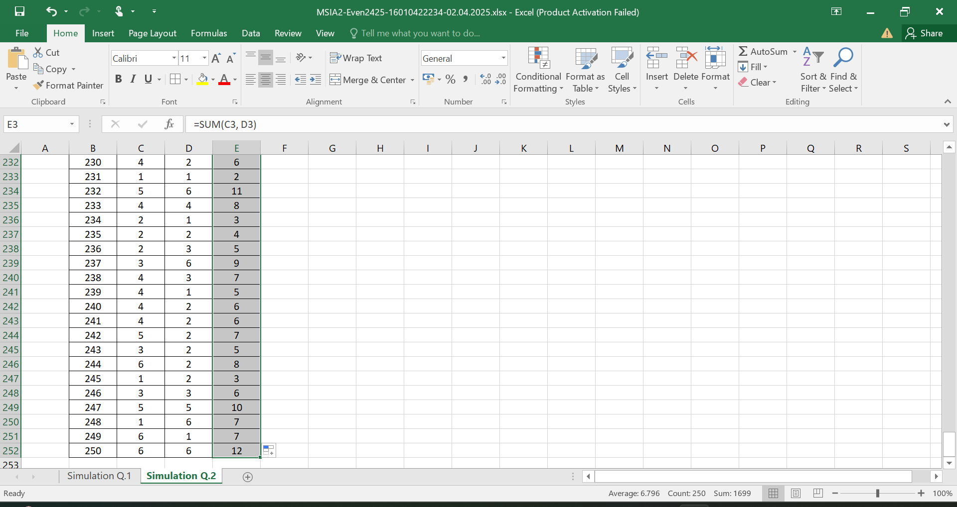

Creating Bins for the Histogram.

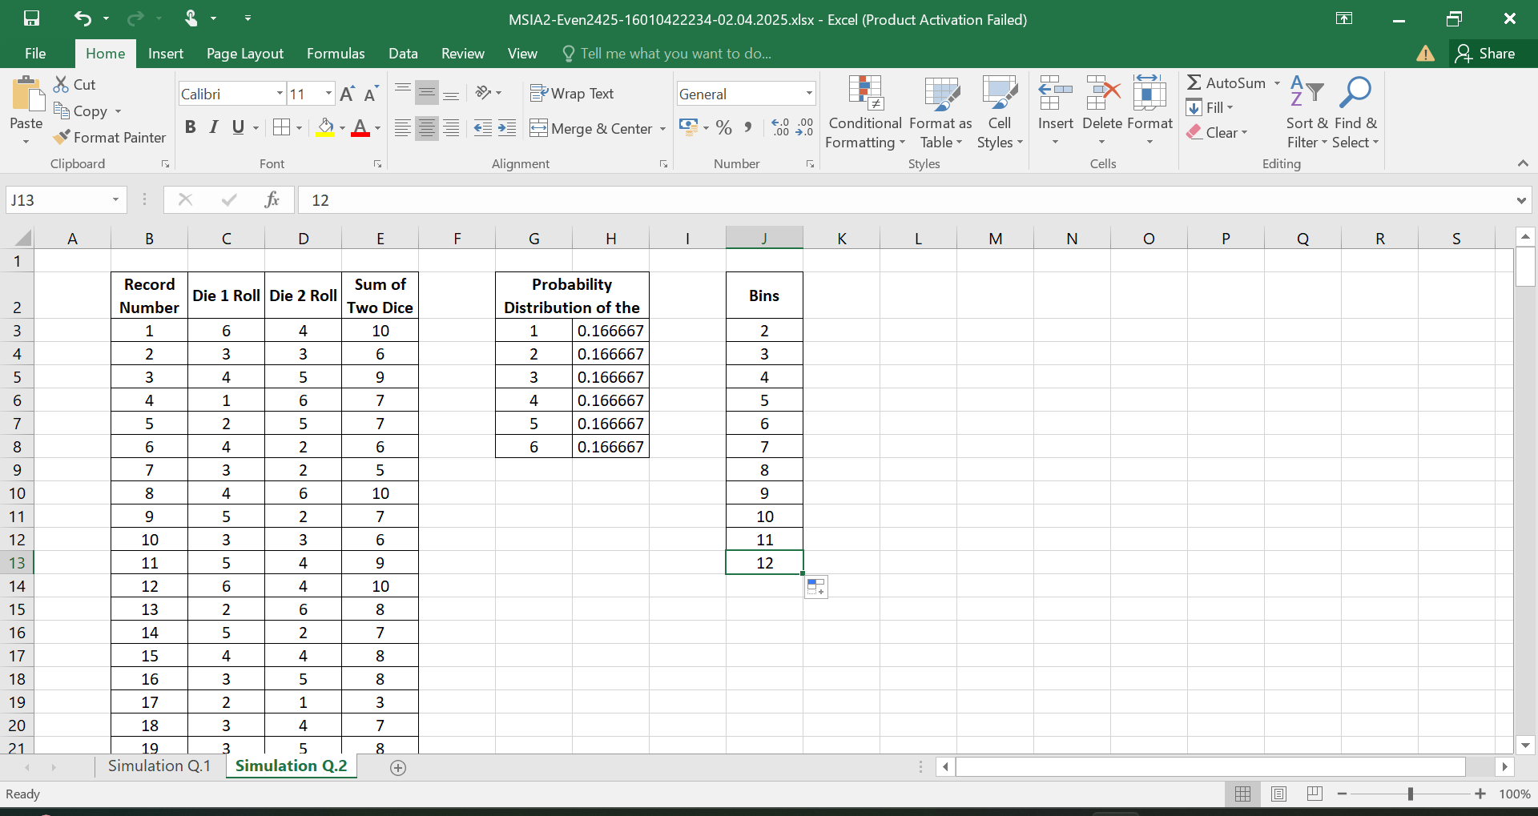

Click on Data Analysis and Open the Histogram Tool.

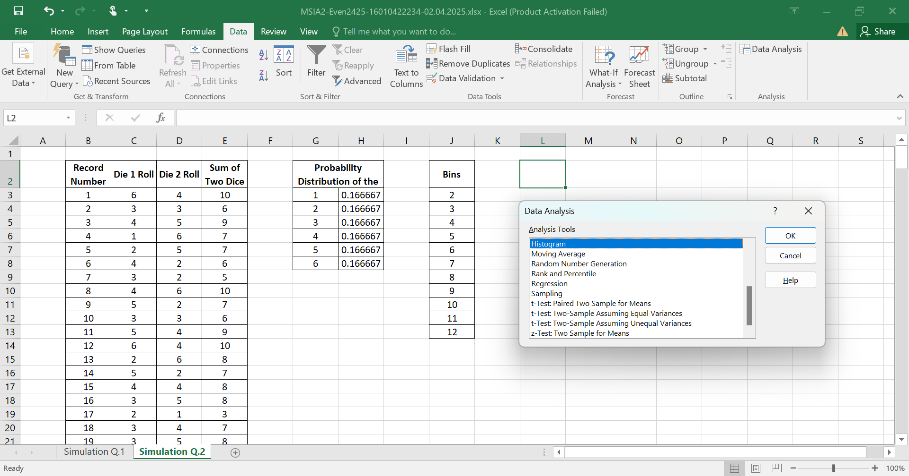

Configure the Histogram Settings:

Input Range: Select the column with the die rolls.

Bin Range: Select the bins created.

Check Labels if your selection includes column headers.

Choose Output Range and select an empty area in the current sheet.

Check Chart Output to create a histogram chart automatically.

